Demo link : https://drive.google.com/file/d/18C61itAUcULcNt8OR3e2nthye2zoJcSr/view?usp=sharing

Github link :
https://github.com/chaitanyaponnada/Docspot-seamless-appointment-booking

Landing Page : Welcoming interface for users.

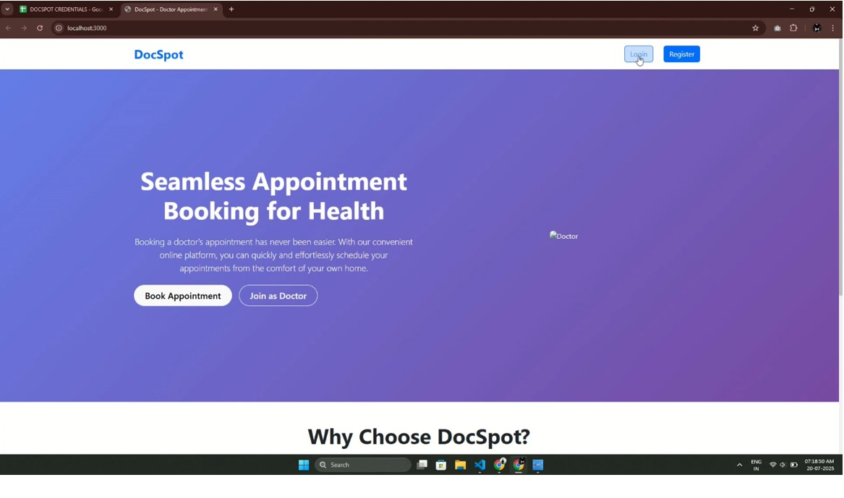

Login Page : Secure login interface.

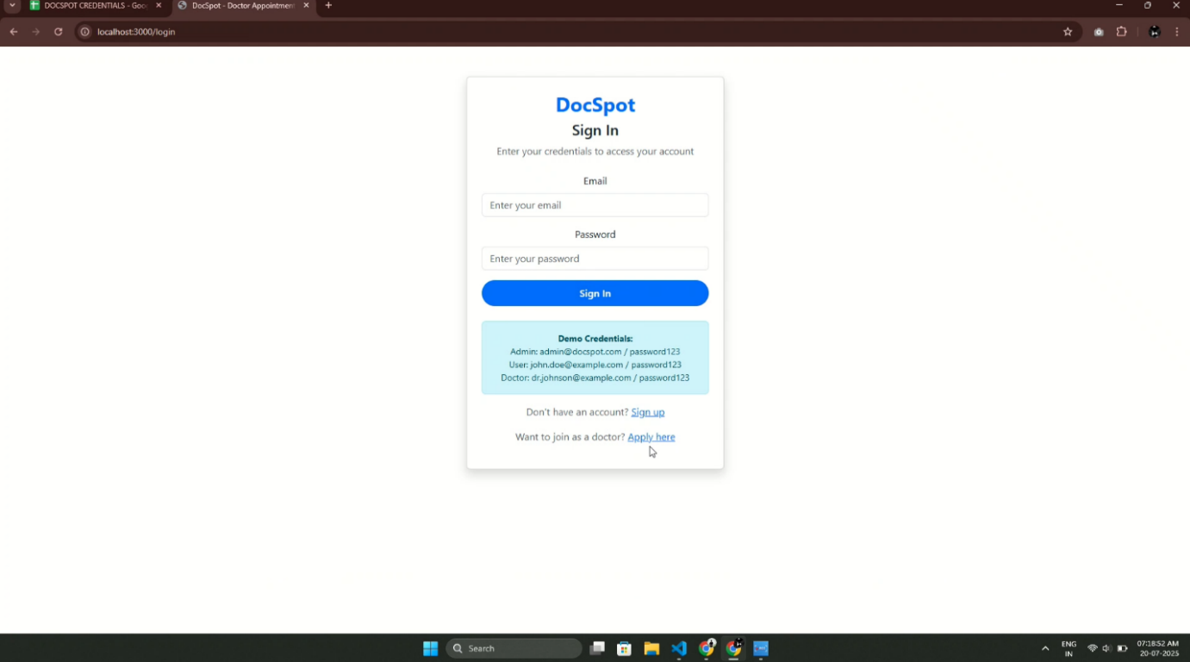

User Dashboard : Patient interface for browsing and booking.

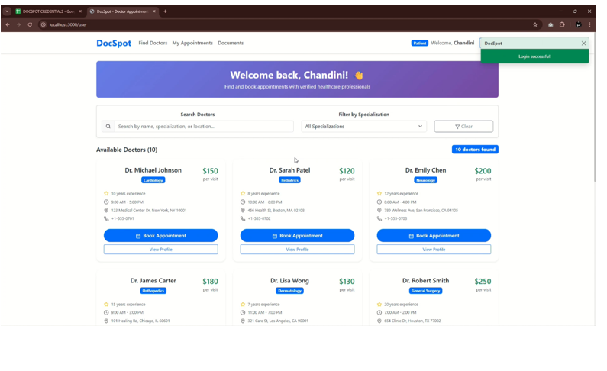

Doctor Dashboard : Appointment and patient management for doctors
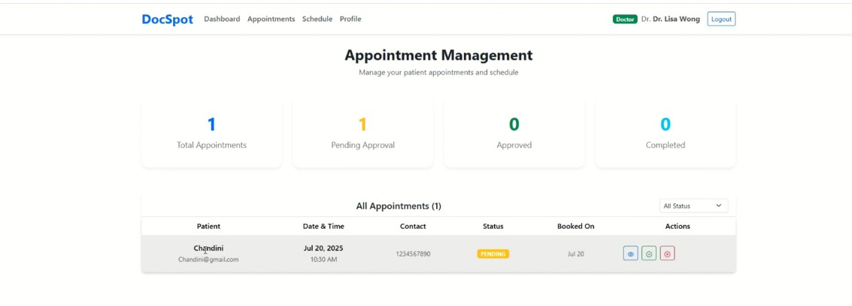

Admin Dashboard : Overview for platform management
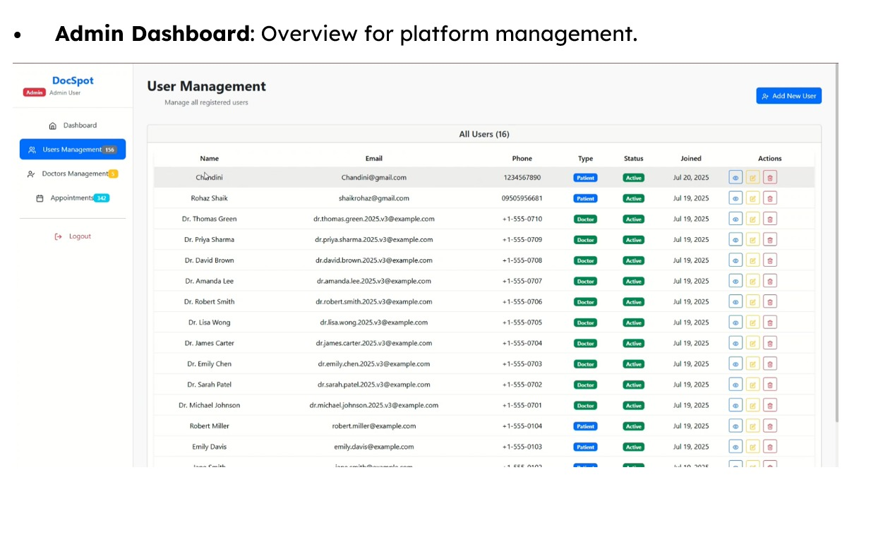

- Book Appointment Page : Appointment booking form

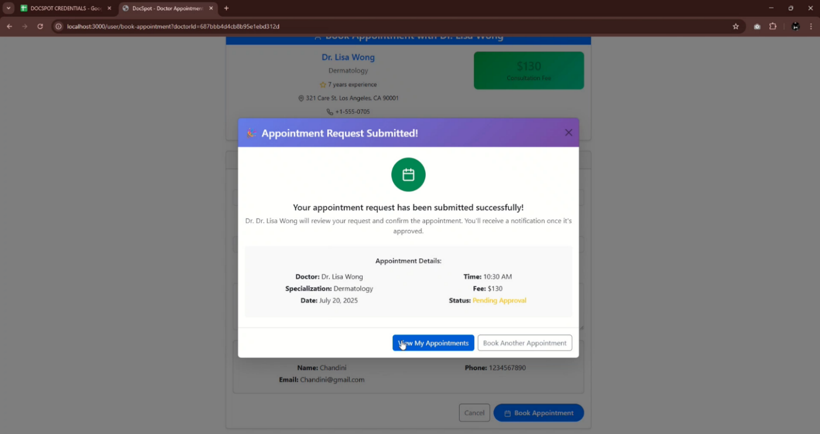

- Booking History Page : Booking history for users.
